Birla Institute of Technology and Science, Pilani
2nd Semester 2010-11
Probability and Statistics
Practice problems on conditional probabilities and Bayes’ theorem
Some problems in the text have some ambiguity or errors. The following is the list of problems from the text which need not be attempted : Solved Ex. 2.4.1, Exercises 11, 35, 36, 41 from ch. 2.
Instead, the following problems are recommended for practice.
- In a medical survey conducted by a hospital, it was found that, of all the cancer deaths 20% were due to oral cancer and 30% due to lung cancer. It was also found that 60% of all cancer ailments result in death and 40% of all cancer patients have oral cancer. Find the probability that (i) a patient with oral cancer dies, (ii) a cancer patient has lung cancer and he dies. Identify the sample space and all relevant events.

Soln : S=The set of all cancer ailments is the sample space.
Events are A = Set of all cancer ailments resulting in death,
B = Set of all cancer ailments with oral cancer,
C= Set of all cancer ailments with lung cancer
P[C|A}=0.3, P[B|A]=0.2, P[A]=0.6 and P[B]=0.4 is known.
(i)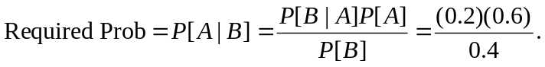
(ii)

- On winning the toss on a random day in November, Dhoni is likely to choose to bat with probability 0.1 if it is a rainy day and is likely to choose to bat with probability 0.7 if it is a non-rainy day. Among the November days on which Dhoni wins the toss, 3% of the days are rainy. If on a random day in November on which Dhoni wins the toss, he has chosen to bat, what is the probability that the day is rainy? If Dhoni has chosen to field on a random day in November on which he won the toss, what is the probability that the day is rainy?

Soln : S = The set of all days in Nov. on which Dhoni wins the toss, is the sample space.
A= Set of all Nov. days on which Dhoni wins the toss that are rainy
B = Set of all Nov. days on which Dhoni wins the toss and chooses to bat.
We know
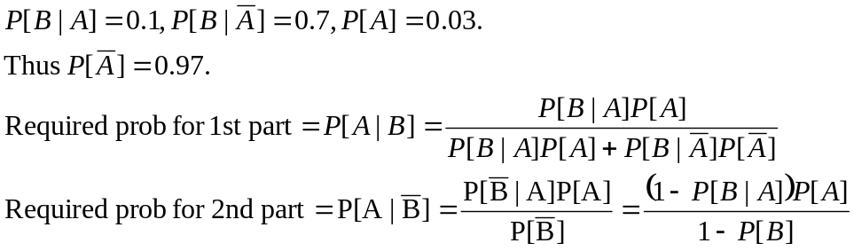

- Draw a card randomly from a pack of cards. Then without putting it back, shuffle the pack well and then pick the top card. Record the drawn cards in sequence. Let A : first card is an ace and B : second card is a spade. Are A and B independent? Let C : first card is an ace and D : second card is an ace. Are C and D independent? Justify your answers.

Soln : Let E : the first card is a spade.
To find P[B}, we use event E thus.
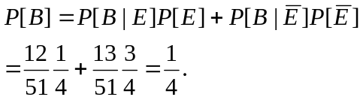
On the other hand,
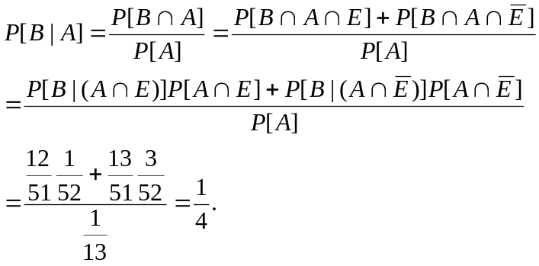
Thus A, B are independent.
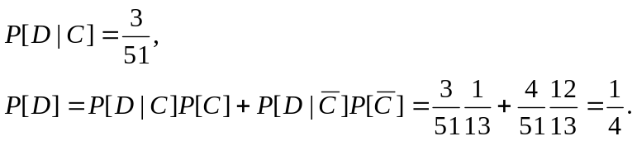
Thus C, D are not independent.

- Give 3 events which are pair-wise independent but not independent. Justify.
- In a satellite launch operation, the probability of the failure of launch is: 0.01 when for the system both the software and the hardware are approved, 0.25 when the software is approved but the hardware is not, 0.3 when the hardware is approved but the software is not, and 0.6 when neither the software nor the hardware is approved. The probabilities are 0.5, 0.3 and 0.75 that respectively the software is approved, the hardware is approved, at least one of the software or hardware is approved. Find the probability that (a) the satellite launch fails, (b) both the software and the hardware were approved given that the satellite launch succeeded.

Soln : Events be A : launch is failure, B : the software is approved, C : the hardware is approved.
Known :
Hence
- By Total prob theorem, P[A]=(0.01)(0.05) + (0.3)(0.25) + (0.25)(0.45) + (0.6)(0.25).

- Suppose 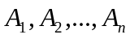are events of a sample space with 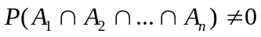then show that .
- A random number generator generates a sequence of 0’s and 1’s. The probability that any 0 is followed by a 1 is 0.4 while the probability that any 1 is followed by a 0 is 0.7. The value of any digit of the sequence depends only on the previous digit and not on digits prior to it. Find the probability that a 1 is followed by two 1’s, then a 0 and then a 1. If the probability that the first digit is 1 is 0.2, find the probability that the sequence is 0010110.

Soln : Let
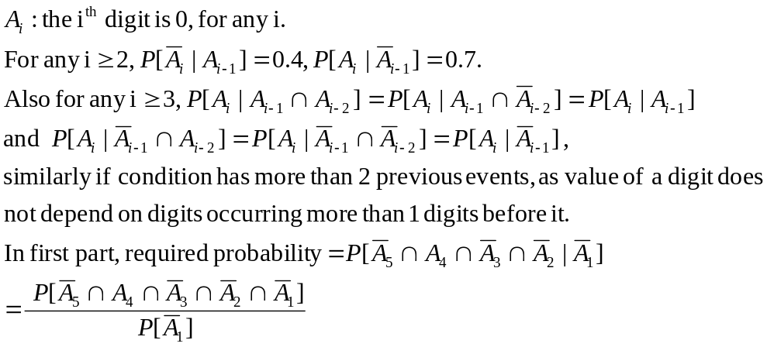
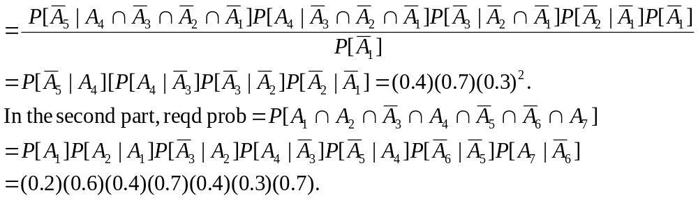
- Urn 1, Urn 2, …, Urn 5 each contain p white and q black balls. One randomly chosen ball is transferred from Urn 1 to Urn 2, next one randomly chosen ball is transferred from Urn 2 to Urn 3, and so on till finally one randomly chosen ball is transferred from Urn 4 to Urn 5. If the ball transferred from Urn 1 to Urn 2 is white, what is the probability the ball transferred from Urn 4 to Urn 5 is white?

Hint: Let A_{i} : ball transferred from Urn I to Urn (i+1) is white. To find P[A₄ |A₁].
Draw the tree diagram starting with A₁ indicating all further possibilities and corresponding conditional probabilities. Count all the desirable paths in the tree and using them find the required probability.

